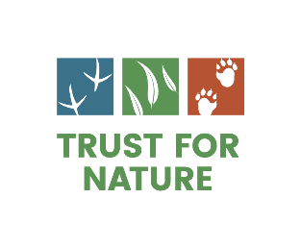

**Covenanted properties for sale**

Thank you for your interest in listing your property on trustfornature.org.au. It will help you find a like-minded buyer. Some reminders before you put your property on the market:

* The deed of covenants needs to be included in the sales documentation (Section 32). You might also consider including the covenant management plan as extra information for prospective buyers.
* As stipulated in the covenant deed, please remember to let us know when you have sold your property. We can then organise a stewardship visit with the new owners as soon as possible to highlight the special features of the property and discuss any queries they have. Call 8631 5888.

Your property will feature on Trust for Nature’s website until you notify us that you have sold the property or wish the listing to be taken down. We wish you all the very best in finding a buyer who loves your place and its plants and animals as much as you do.

To have your property listed, please complete the form below and email to [properties@tfn.org.au](mailto:properties@tfn.org.au) with 3-5 high resolution colour photos (JPEG or PNG; larger than 1MB and less than 5MB) of your property.

For queries about your listing your property on the website please call Trust for Nature on 8631 5888. For queries about selling your covenanted property please email [properties@tfn.org.au.](mailto:properties@tfn.org.au)

**Property details**

|  |  |
| --- | --- |
| Property name (or heading you would like us to use to list the property) |  |
| Brief description (200 words) | *Tip: describe what makes the property special to you.* |
| Location (town/vicinity) |  |
| Total property size (ha) |  |
| Covenant size (ha) |  |
| **Contact details for further information (this must be the owner of the property and not a real estate agent)** | |
| Name |  |
| Phone |  |
| Email |  |